**Práctica Calificada 01**

**Apellidos y Nombres: Vera Yauri Victor**

* Indicaciones: La práctica debe ser desarrollada completamente en el documento
* La solución debe enviarse al aula virtual.
* El desarrollo de la práctica es individual
* El tiempo asignado es de 50 minutos
* **La entrega fuera de hora representa: 07 puntos menos, pasado los 15 minutos representa 15 puntos menos.**

1. **Ordenamiento**
   1. **Preg01.** Dado un arreglo llamado **Lista**, ordénelos utilizando el método de burbuja.

|  |  |  |  |  |  |  |
| --- | --- | --- | --- | --- | --- | --- |
| **Posición**  **i** | 0 | 1 | 2 | 3 | 4 | 5 |
| **Lista** | 5 | -100 | 100 | 30 | 35 | 0 |

**iteración (i=0):**

|  |  |  |  |  |  |  |
| --- | --- | --- | --- | --- | --- | --- |
| **Lista Original** | 5 | -100 | 100 | 30 | 35 | 0 |
| **j=1** | -100 | 5 | 100 | 30 | 35 | 0 |
| **j=2** | -100 | 5 | 100 | 30 | 35 | 0 |
| **j=3** | -100 | 5 | 30 | 100 | 35 | 0 |
| **j=4** | -100 | 5 | 30 | 35 | 100 | 0 |
| **j=5** | -100 | 5 | 30 | 35 | 0 | 100 |

**iteración (i=1):**

|  |  |  |  |  |  |  |
| --- | --- | --- | --- | --- | --- | --- |
| **Lista de la iteración anterior** | -100 | 5 | 30 | 35 | 0 | 100 |
| **j=2** | -100 | 5 | 30 | 35 | 0 | 100 |
| **j=3** | -100 | 5 | 30 | 35 | 0 | 100 |
| **j=4** | -100 | 5 | 30 | 0 | 35 | 100 |
| **j=5** | -100 | 5 | 30 | 0 | 35 | 100 |

**iteración (i=2):**

|  |  |  |  |  |  |  |
| --- | --- | --- | --- | --- | --- | --- |
| **Lista de la iteración anterior** | -100 | 5 | 30 | 0 | 35 | 100 |
| **j=3** | -100 | 5 | 30 | 0 | 35 | 100 |
| **j=4** | -100 | 5 | 30 | 0 | 35 | 100 |
| **j=5** | -100 | 5 | 0 | 30 | 35 | 100 |

**iteración (i=3):**

|  |  |  |  |  |  |  |
| --- | --- | --- | --- | --- | --- | --- |
| **Lista de la iteración anterior** | -100 | 5 | 0 | 30 | 35 | 100 |
| **j=4** | -100 | 5 | 0 | 30 | 35 | 100 |
| **j=5** | -100 | 0 | 5 | 30 | 35 | 100 |

**iteración (i=4):**

|  |  |  |  |  |  |  |
| --- | --- | --- | --- | --- | --- | --- |
| **Lista de la iteración anterior** | -100 | 0 | 5 | 30 | 35 | 100 |
| **j=5** | -100 | 0 | 5 | 30 | 35 | 100 |

**Entonces el resultado es:**

|  |  |  |  |  |  |  |
| --- | --- | --- | --- | --- | --- | --- |
| **Lista ordenada:** | **-100** | **0** | **5** | **30** | **35** | **100** |

* 1. **Preg02.** Utilizando el mismo proceso de la Preg01, ordene la lista utilizando el método de burbuja. *(Diseñe su plantilla como en la pregunta anterior)*

|  |  |  |  |  |  |  |  |  |
| --- | --- | --- | --- | --- | --- | --- | --- | --- |
| **Posición**  **i** | 0 | 1 | 2 | 3 | 4 | 5 | 6 | 7 |
| **Lista** | 56 | 88 | 22 | 41 | -10 | -7 | 5 | 26 |

**Iteración (i=0):**

|  |  |  |  |  |  |  |  |  |
| --- | --- | --- | --- | --- | --- | --- | --- | --- |
| **Lista Original** | 56 | 88 | 22 | 41 | -10 | -7 | 5 | 26 |
| **j=1** | 56 | 88 | 22 | 41 | -10 | -7 | 5 | 26 |
| **j=2** | 56 | 22 | 88 | 41 | -10 | -7 | 5 | 26 |
| **j=3** | 56 | 22 | 41 | 88 | -10 | -7 | 5 | 26 |
| **j=4** | 56 | 22 | 41 | -10 | 88 | -7 | 5 | 26 |
| **j=5** | 56 | 22 | 41 | -10 | -7 | 88 | 5 | 26 |
| **j=6** | 56 | 22 | 41 | -10 | -7 | 5 | 88 | 26 |
| **j=7** | 56 | 22 | 41 | -10 | -7 | 5 | 26 | 88 |

**Iteración (i=1):**

|  |  |  |  |  |  |  |  |  |
| --- | --- | --- | --- | --- | --- | --- | --- | --- |
| **Lista de la iteración anterior** | 56 | 22 | 41 | -10 | -7 | 5 | 26 | 88 |
| **j=2** | 22 | 56 | 41 | -10 | -7 | 5 | 26 | 88 |
| **j=3** | 22 | 41 | 56 | -10 | -7 | 5 | 26 | 88 |
| **j=4** | 22 | 41 | -10 | 56 | -7 | 5 | 26 | 88 |
| **j=5** | 22 | 41 | -10 | -7 | 56 | 5 | 26 | 88 |
| **j=6** | 22 | 41 | -10 | -7 | 5 | 56 | 26 | 88 |
| **j=7** | 22 | 41 | -10 | -7 | 5 | 26 | 56 | 88 |

**Iteración (i=2):**

|  |  |  |  |  |  |  |  |  |
| --- | --- | --- | --- | --- | --- | --- | --- | --- |
| **Lista de la iteración anterior** | 22 | 41 | -10 | -7 | 5 | 26 | 56 | 88 |
| **j=3** | 22 | 41 | -10 | -7 | 5 | 26 | 56 | 88 |
| **j=4** | 22 | -10 | 41 | -7 | 5 | 26 | 56 | 88 |
| **j=5** | 22 | -10 | -7 | 41 | 5 | 26 | 56 | 88 |
| **j=6** | 22 | -10 | -7 | 5 | 41 | 26 | 56 | 88 |
| **j=7** | 22 | -10 | -7 | 5 | 26 | 41 | 56 | 88 |

**Iteración (i=3):**

|  |  |  |  |  |  |  |  |  |
| --- | --- | --- | --- | --- | --- | --- | --- | --- |
| **Lista de la iteración anterior** | 22 | -10 | -7 | 5 | 26 | 41 | 56 | 88 |
| **j=4** | -10 | 22 | -7 | 5 | 26 | 41 | 56 | 88 |
| **j=5** | -10 | -7 | 22 | 5 | 26 | 41 | 56 | 88 |
| **j=6** | -10 | -7 | 5 | 22 | 26 | 41 | 56 | 88 |
| **j=7** | -10 | -7 | 5 | 22 | 26 | 41 | 56 | 88 |

**Iteración (i=4):**

|  |  |  |  |  |  |  |  |  |
| --- | --- | --- | --- | --- | --- | --- | --- | --- |
| **Lista de la iteración anterior** | -10 | -7 | 5 | 22 | 26 | 41 | 56 | 88 |
| **j=5** | -10 | -7 | 5 | 22 | 26 | 41 | 56 | 88 |
| **j=6** | -10 | -7 | 5 | 22 | 26 | 41 | 56 | 88 |
| **j=7** | -10 | -7 | 5 | 22 | 26 | 41 | 56 | 88 |

**Iteración (i=5):**

|  |  |  |  |  |  |  |  |  |
| --- | --- | --- | --- | --- | --- | --- | --- | --- |
| **Lista de la iteración anterior** | -10 | -7 | 5 | 22 | 26 | 41 | 56 | 88 |
| **j=6** | -10 | -7 | 5 | 22 | 26 | 41 | 56 | 88 |
| **j=7** | -10 | -7 | 5 | 22 | 26 | 41 | 56 | 88 |

**Iteración (i=6):**

|  |  |  |  |  |  |  |  |  |
| --- | --- | --- | --- | --- | --- | --- | --- | --- |
| **Lista de la iteración anterior** | -10 | -7 | 5 | 22 | 26 | 41 | 56 | 88 |
| **j=7** | -10 | -7 | 5 | 22 | 26 | 41 | 56 | 88 |

**Entonces el resultado es:**

|  |  |  |  |  |  |  |  |  |
| --- | --- | --- | --- | --- | --- | --- | --- | --- |
| **Lista ordenada:** | **-10** | **-7** | **5** | **22** | **26** | **41** | **56** | **88** |

* 1. **Preg03.** Ordene la lista utilizando el **método radix**. *(Muestre el paso a paso)*

|  |  |  |  |  |  |  |  |  |  |  |  |
| --- | --- | --- | --- | --- | --- | --- | --- | --- | --- | --- | --- |
| 2561 | 4708 | 1222 | 4110 | 1000 | 7854 | 1234 | 4321 | 1535 | 1521 | 6510 | 1235 |

|  |  |  |  |  |  |  |  |  |  |  |  |
| --- | --- | --- | --- | --- | --- | --- | --- | --- | --- | --- | --- |
| 4589 | 1234 | 5548 | 45 | 4896 | 7745 | 1156 | 5186 | 1189 | 8476 | 2567 | 1879 |

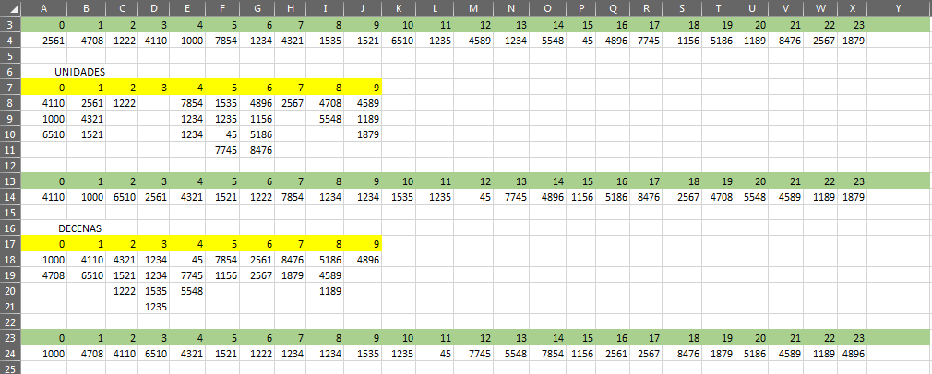

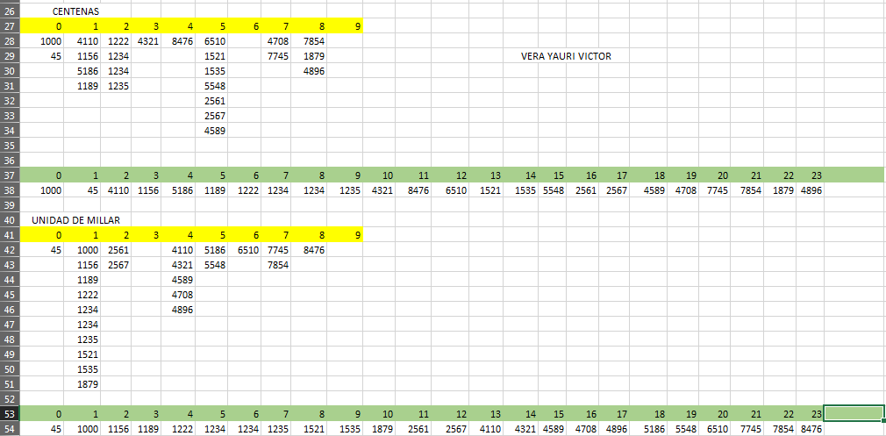

* 1. **Preg04.** Ordene la lista utilizando el método radix. *(Muestre el paso a paso)*

|  |  |  |  |  |  |  |  |  |  |  |  |
| --- | --- | --- | --- | --- | --- | --- | --- | --- | --- | --- | --- |
| 5876 | 58701 | 63288 | 4785 | 25041 | 11 | 5894 | 536 | 78249 | 9991 | 12548 | 1235 |

|  |  |  |  |  |  |  |  |  |  |  |  |
| --- | --- | --- | --- | --- | --- | --- | --- | --- | --- | --- | --- |
| 12458 | 11914 | 24578 | 1247 | 63258 | 1478 | 225 | 36992 | 8456 | 21345 | 7748 | 12042 |

